1. Open Power BI Desktop-> Blank Report

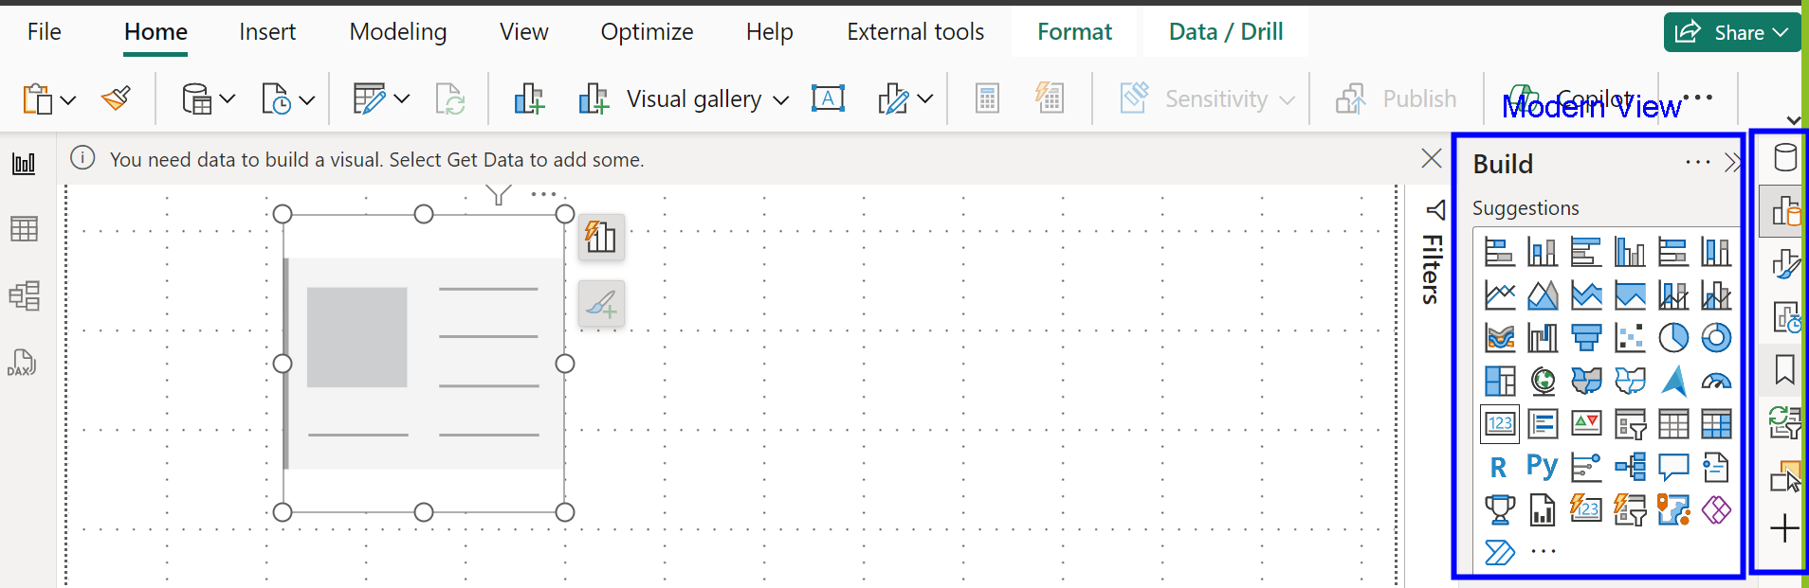

1. Go to File Menu->Options and Settings->Options->

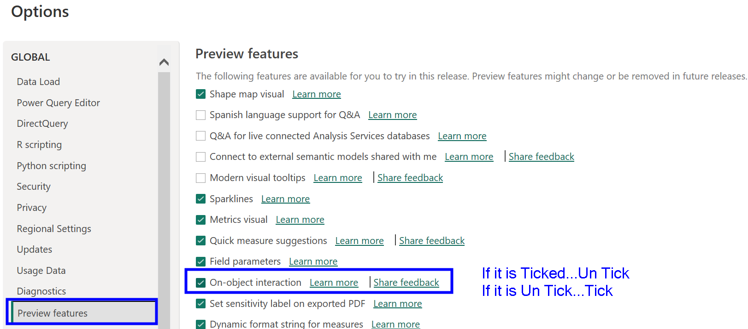

1. Click Ok, Save the application, Close, Open again Power BI Desktop and look at right hand-side options
2. File menu->Save-> provide a name. Go to the location of the file, see the size and document type.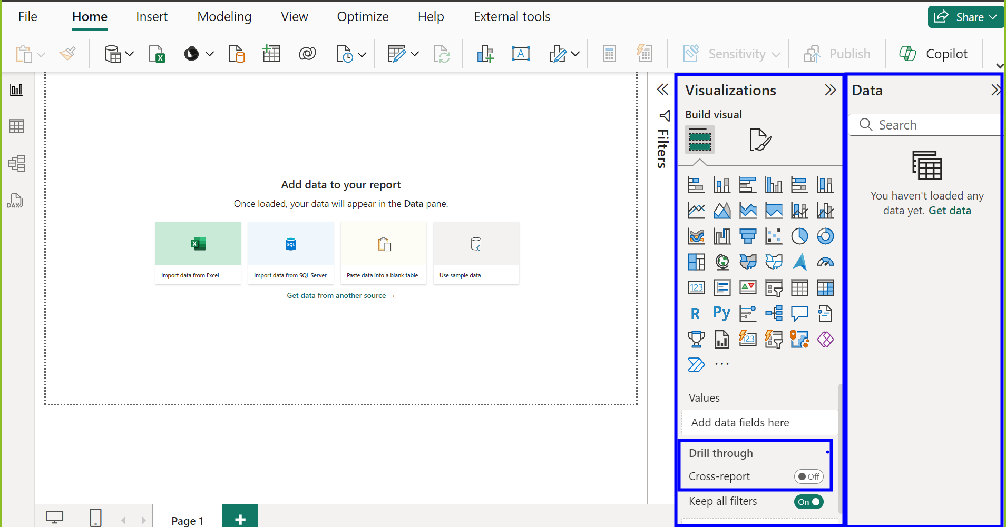
3. Create a table manually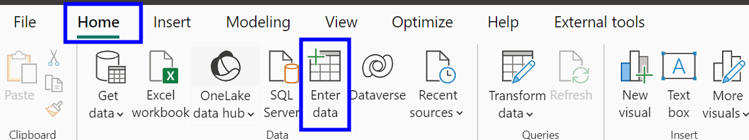

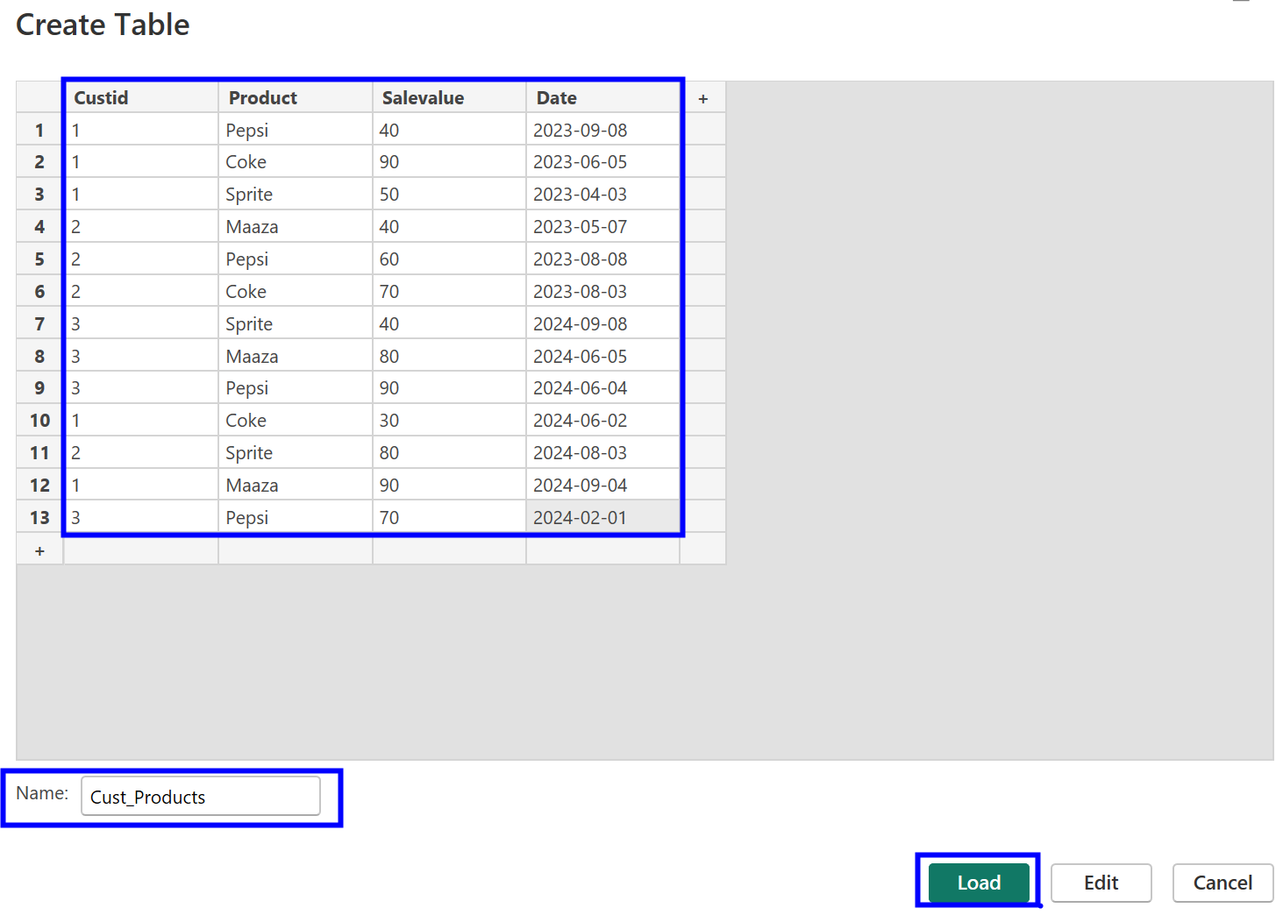

After clicking Load, Go to Table View and Observe the data

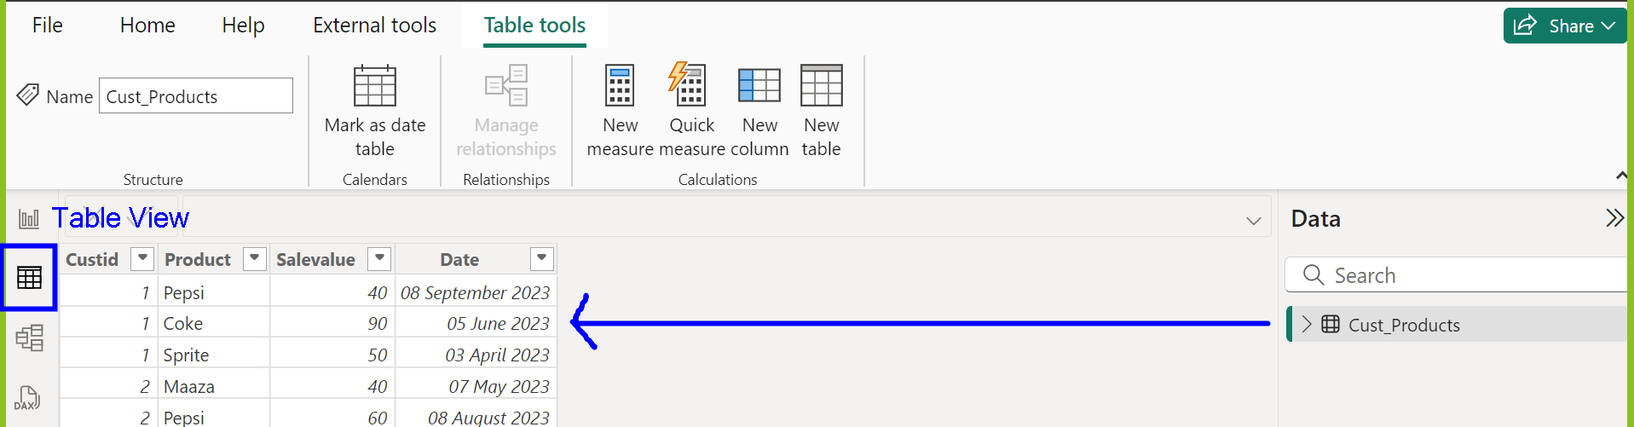

1. Create a Date Table using DAX Language

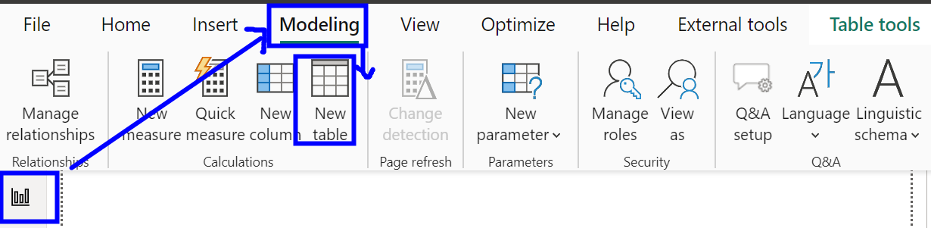

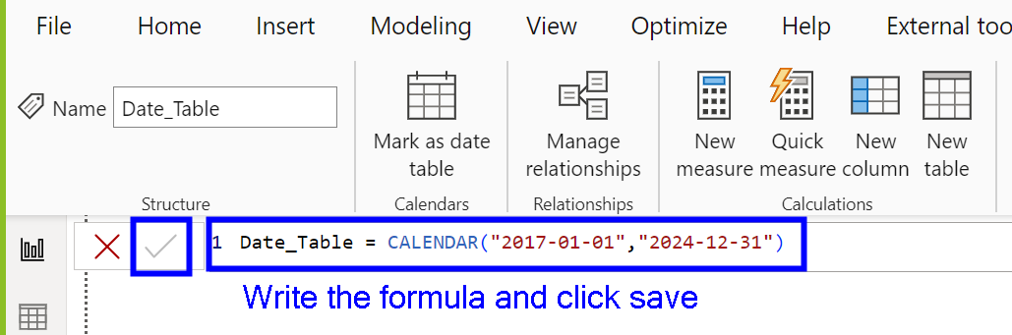

Go to Table View, Observe one column of date values between 2017-01-01 and 2024-12-31

**7.Create calculated columns in the above table**

**Table View-> Right click Date column-> New Column->**

Year = year(Date_Table[Date])

**Table View-> Right click Date column-> New Column->**

Quarter = QUARTER(Date_Table[Date])

**Table View-> Right click Date column-> New Column->**

Month = month(Date_Table[Date])

**Table View-> Right click Date column-> New Column->**

Day = day(Date_Table[Date])

**Table View-> Right click Date column-> New Column->**

Full_Date = format(Date_Table[Date],"yyyy-mmmm-dddd")

**8. Connect Date_Table and Cust_Products table using Date**

Go to Model View-> Connect Date column from Date_Table to Cust_Products table Date

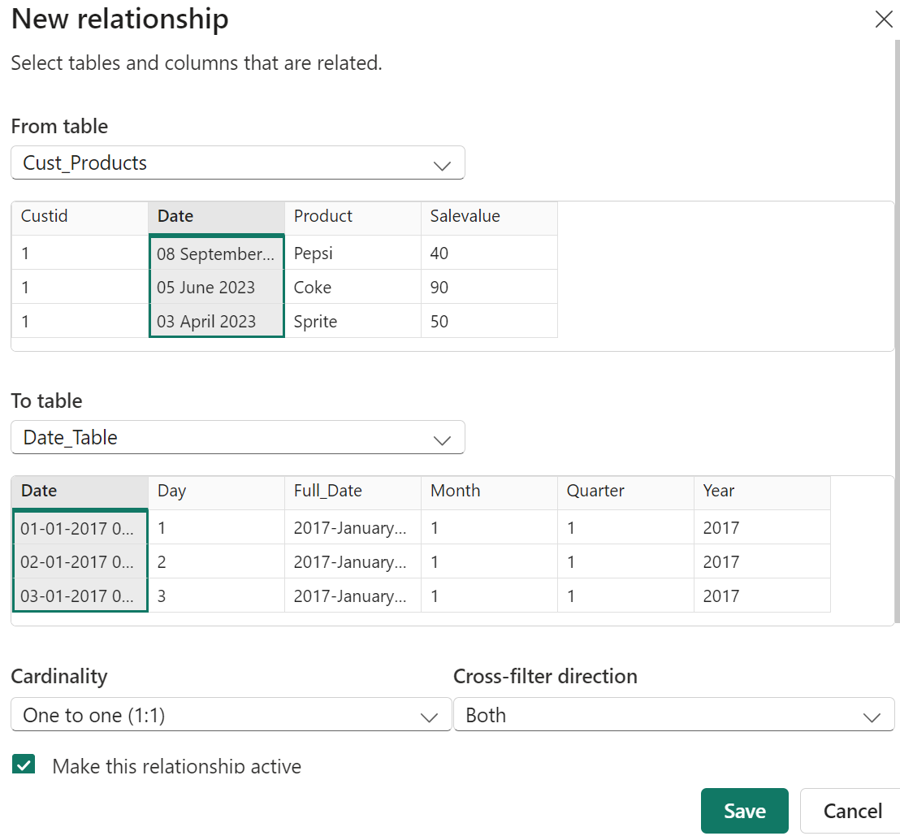

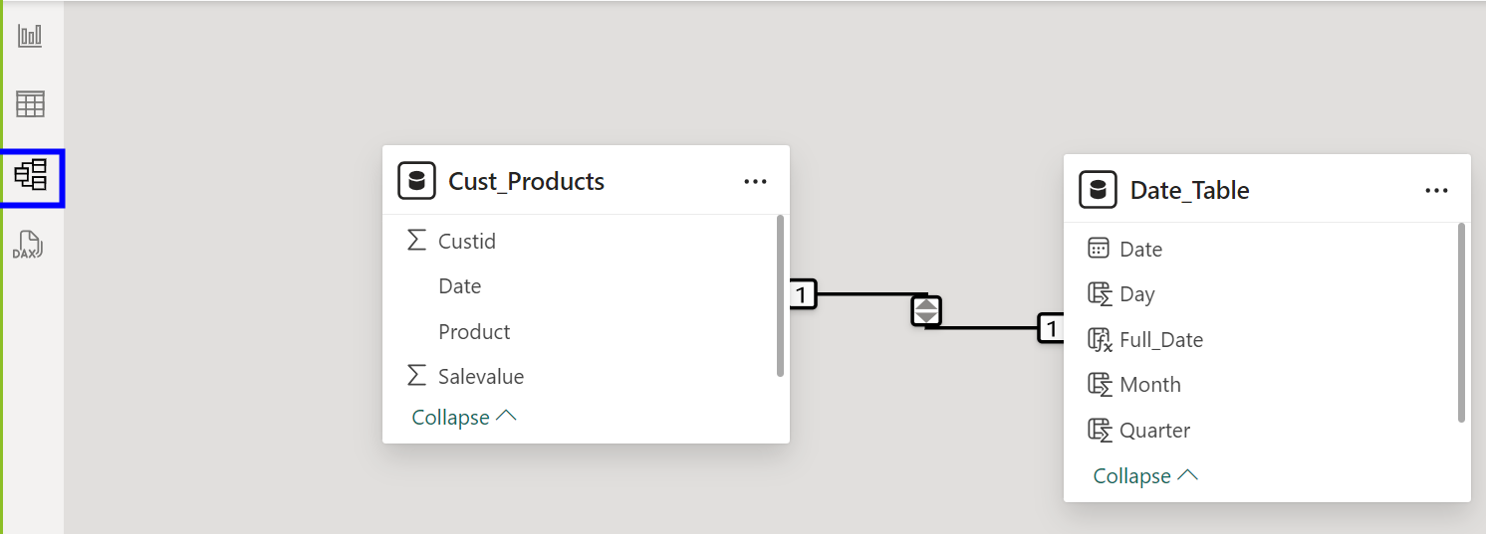

9.Take Matrix visual

Row Section: Year

Column Section: Product

Value Section: SaleValue

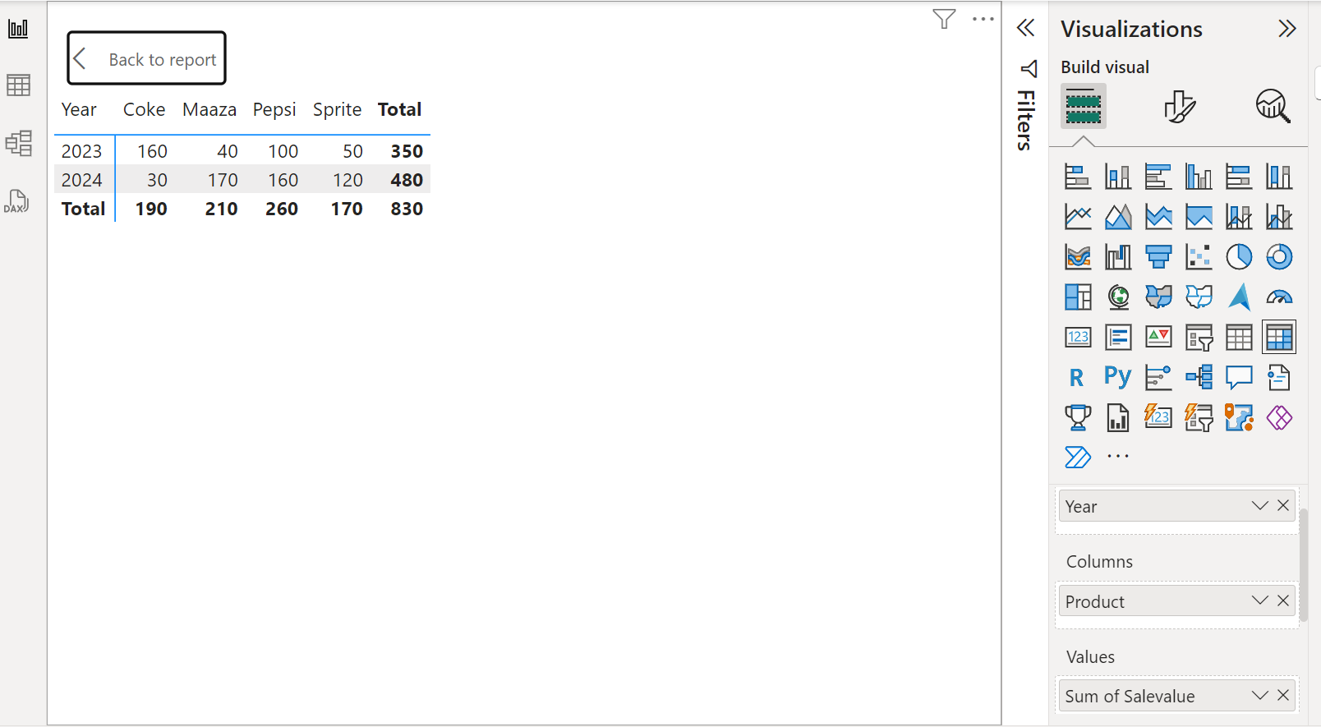

**Just go to Rows Section, place Quarter and Month also**

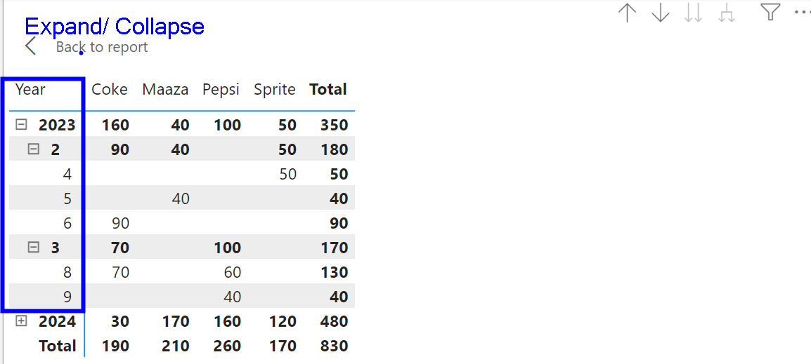

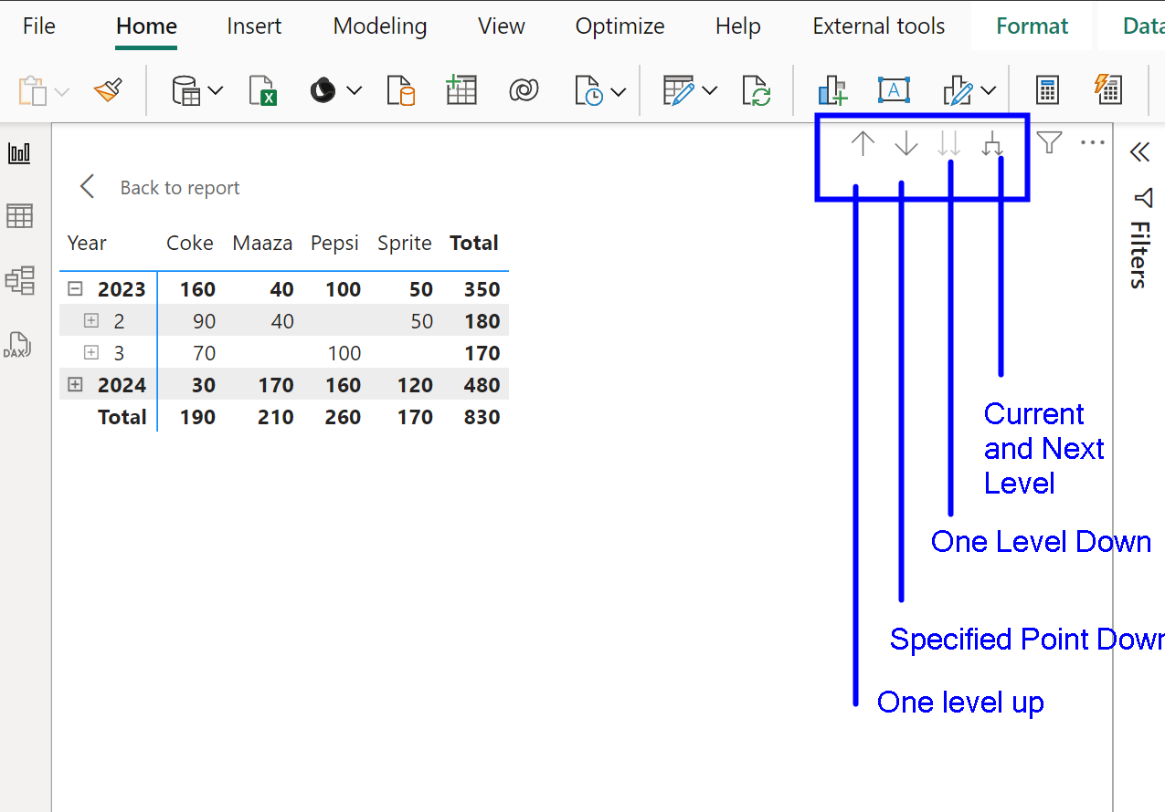

Work on the above drill down and drill up options